Functional Testing
Ask a question
Get an explanation
Generate a quiz
Summarize content
Get a personalized learning plan
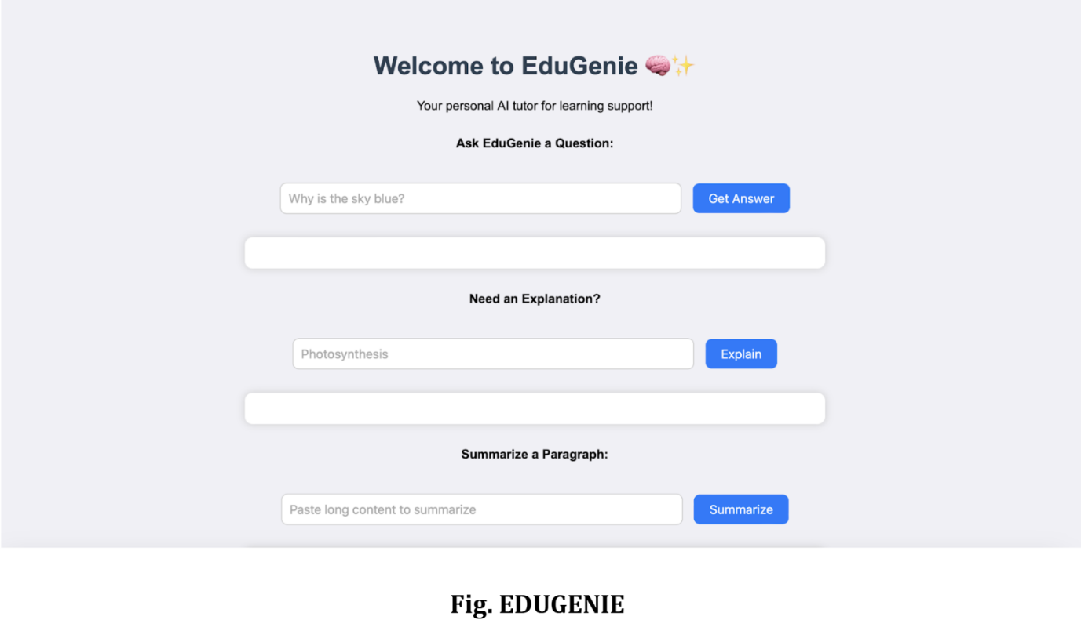
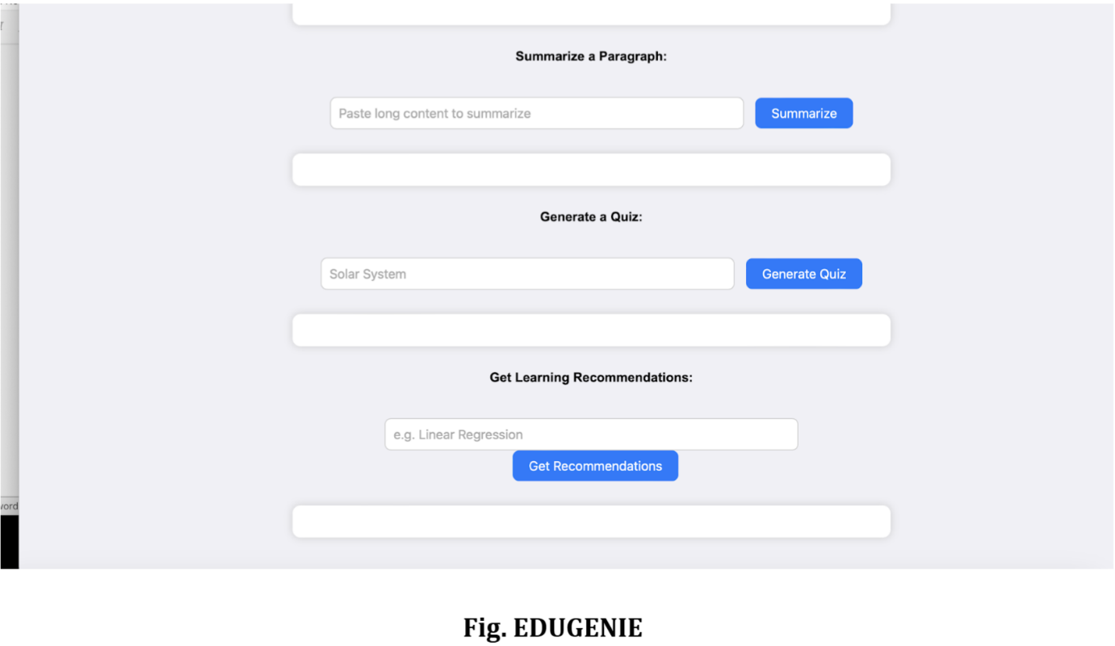

Exploring EduGenie:

Asking questions:
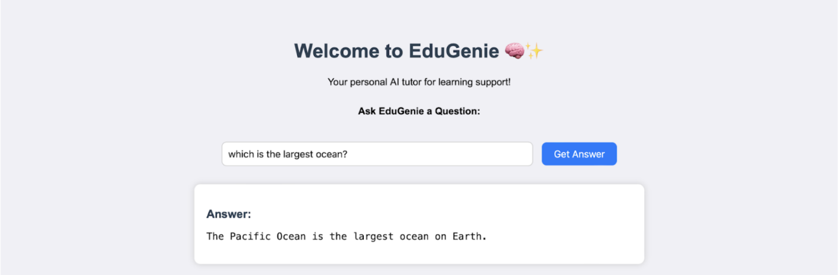
Explanation of any topic:
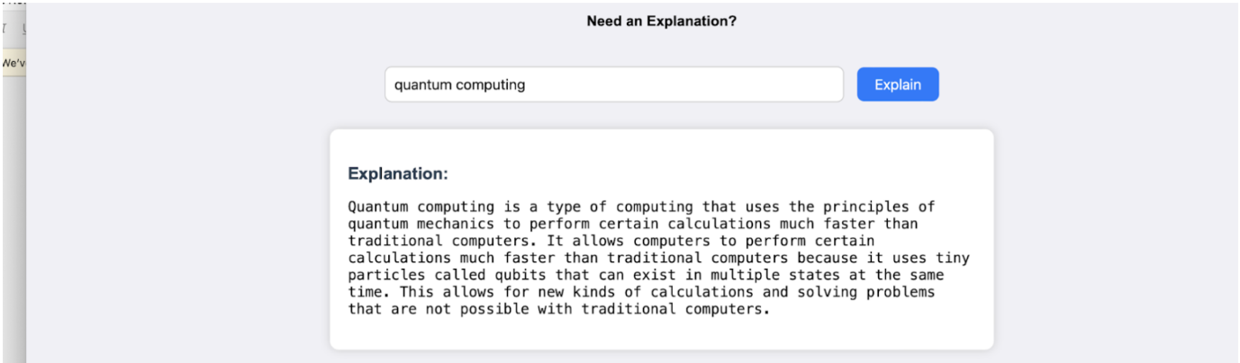
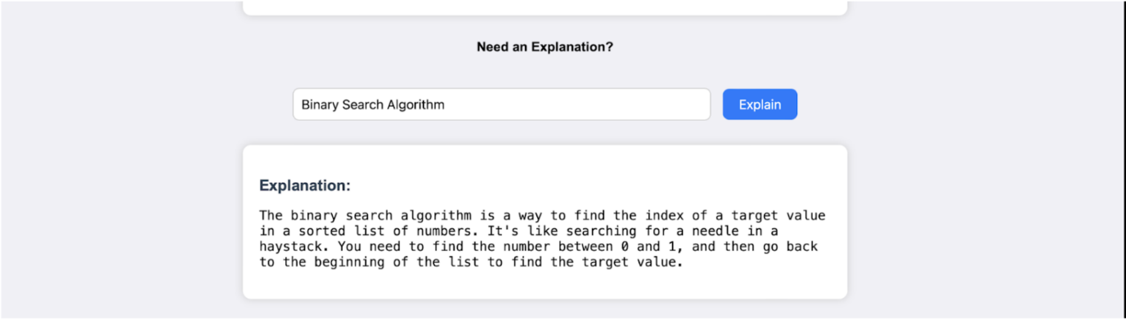
Summarising long paragraphs:
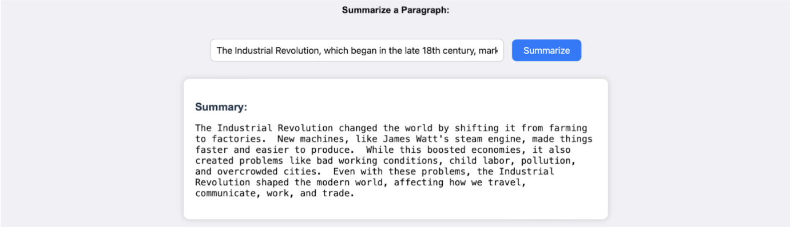
Generating quizzes:
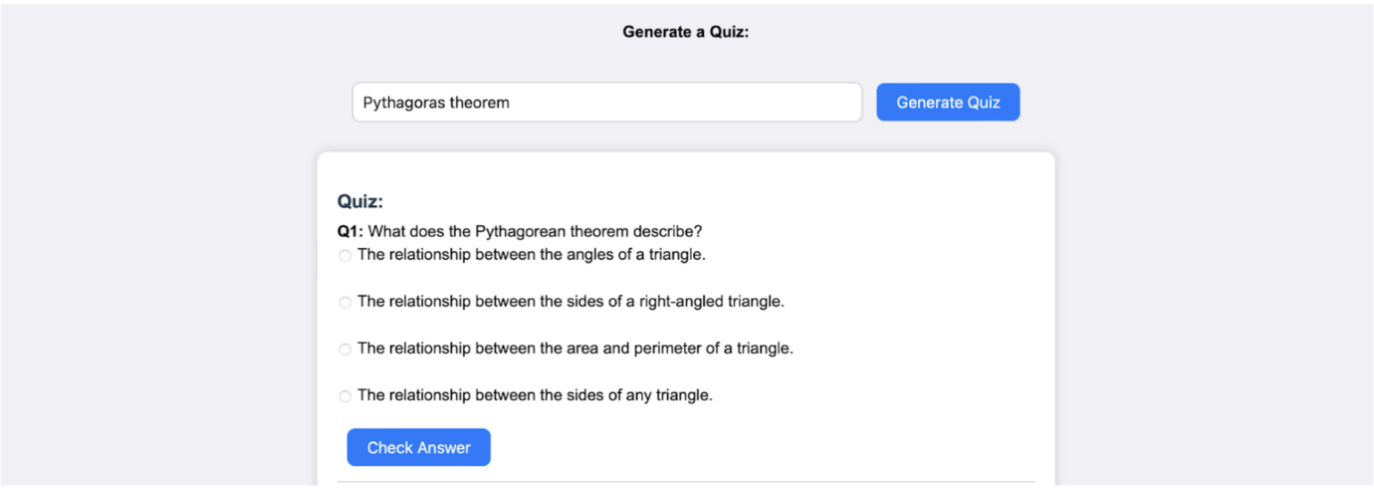
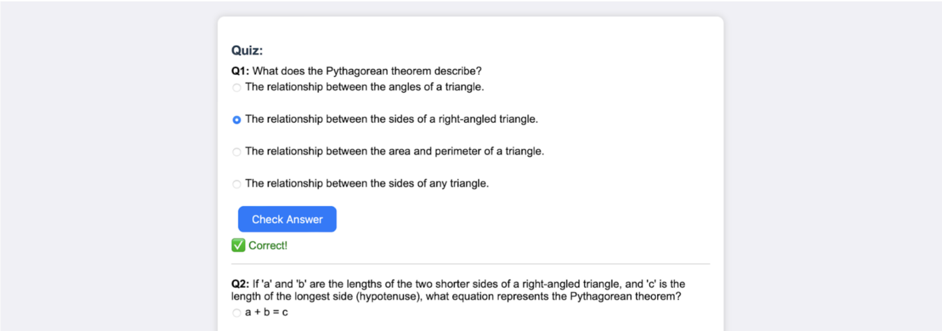
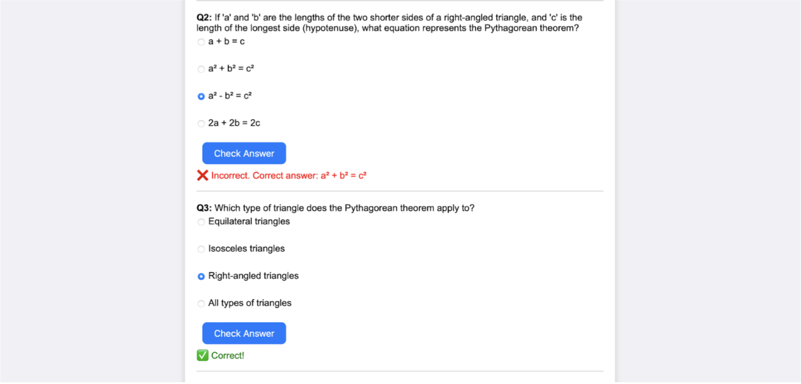
It generates three questions with 4 options each. It corrects the answer if chosen incorrectly.
Guiding with learning recommendations from beginner level to advanced level:
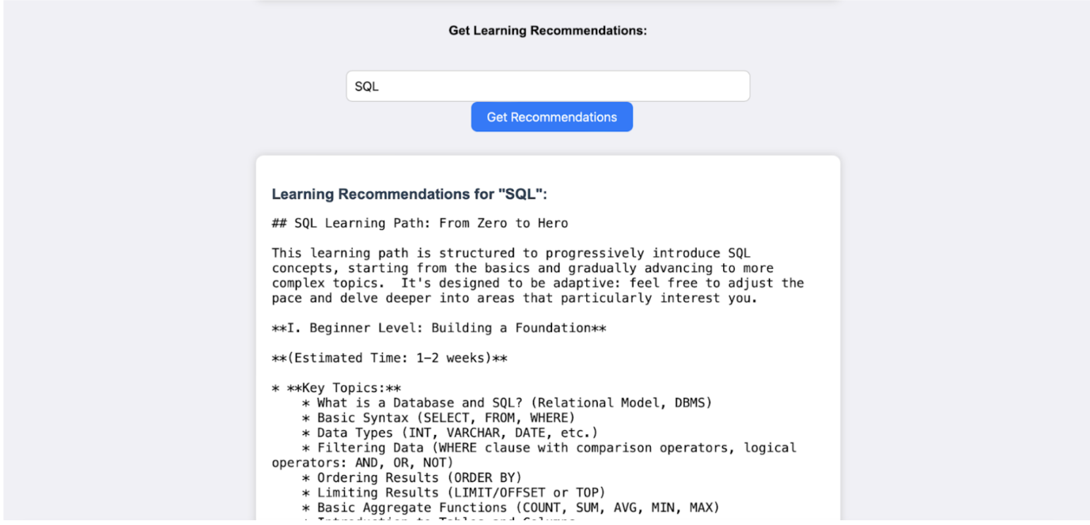
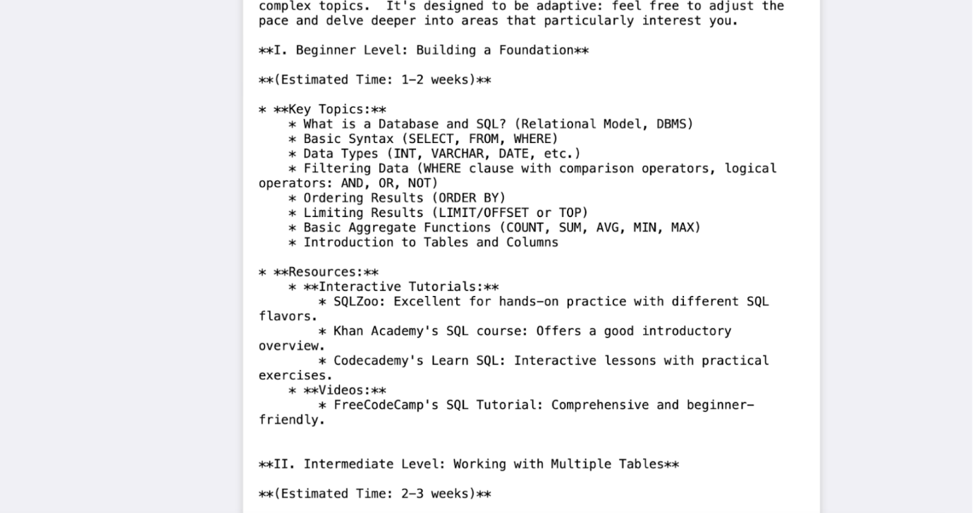
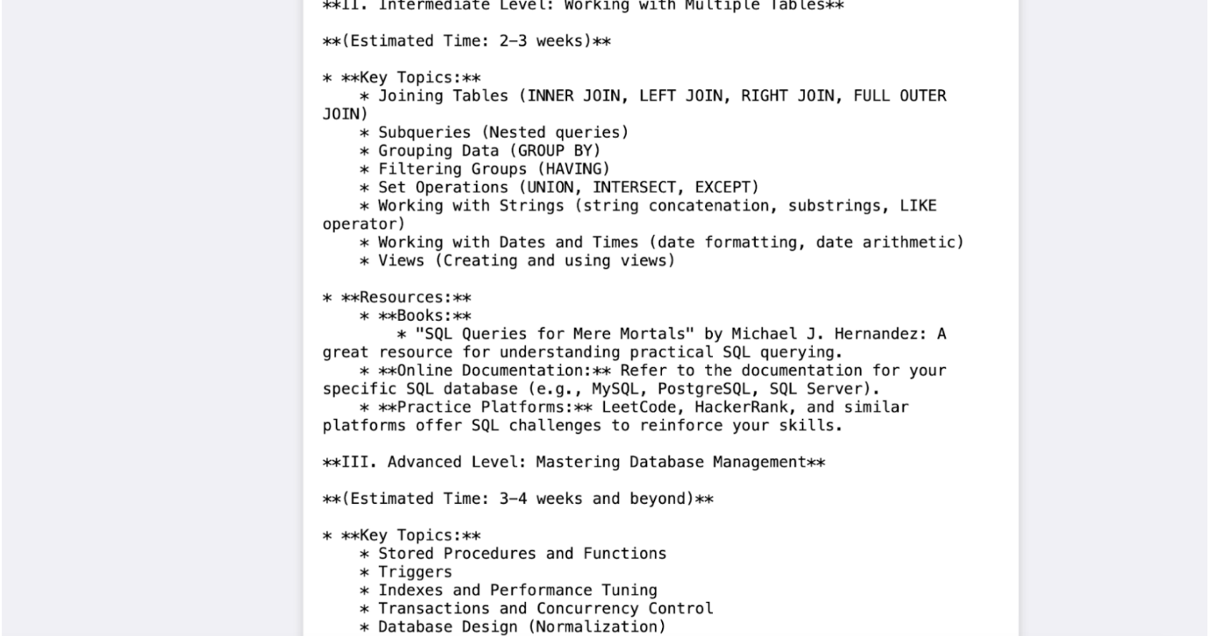
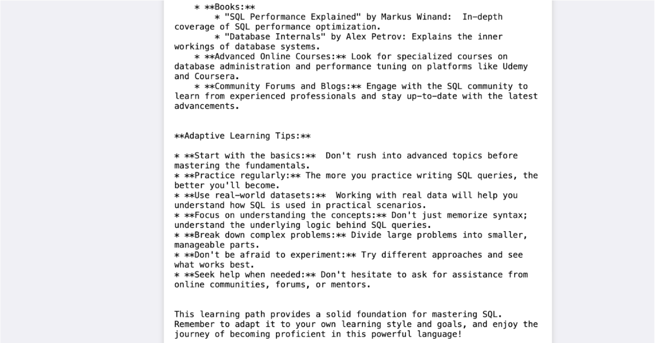
It provides, along with details of resources from where to learn and stepwise guidance throughout.

